REG NO: 22TD0042 NAME: KISHOR KUMAR I
YEAR/SEM/SEC: Y3/S5/B

MINI PROJECT
LIBRARY INFORMATION SYSTEM TYPES OF COMMANDS:

DDL[DATA DEFINITION LANGUAGE]

1.CREATE:

BOOKSS:

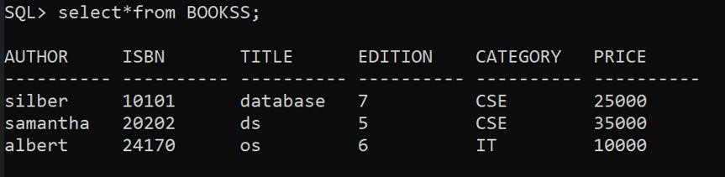
READERS:

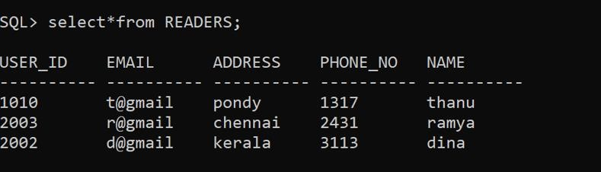

PUBLISHERSS:

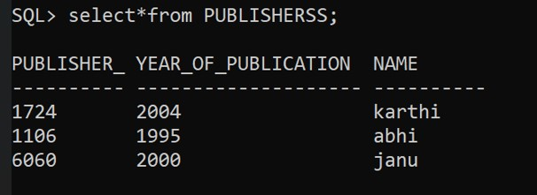

AUTHENTICATION:

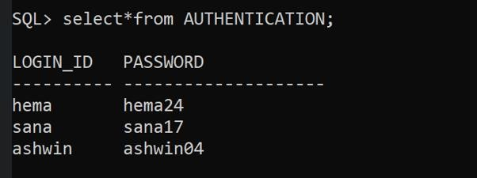

REPORTS:
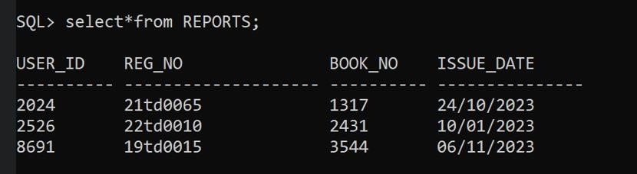
STAFF:

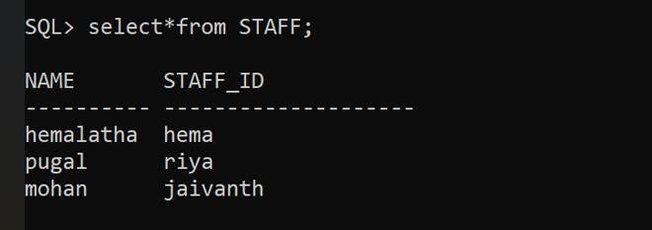

2.ALTER:
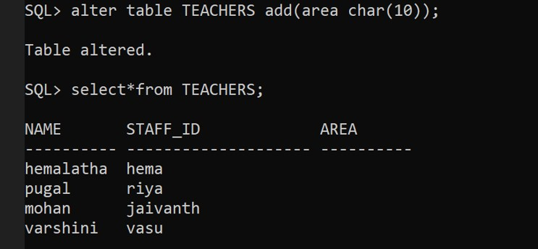
3.DROP:
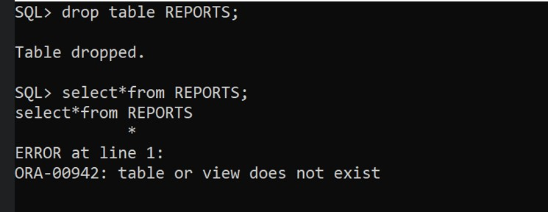

4.TRUNCATE:

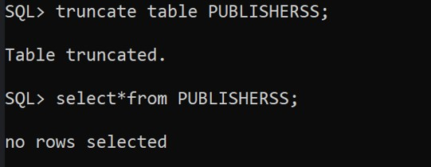

5.RENAME:
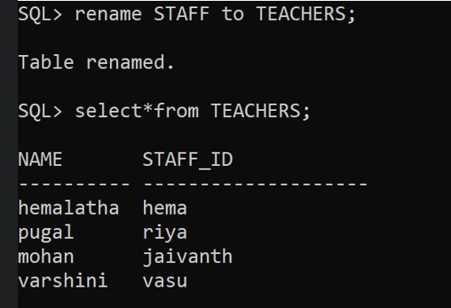

DML[DATA MANIPULATION LANGUAGE]

1.SELECT:
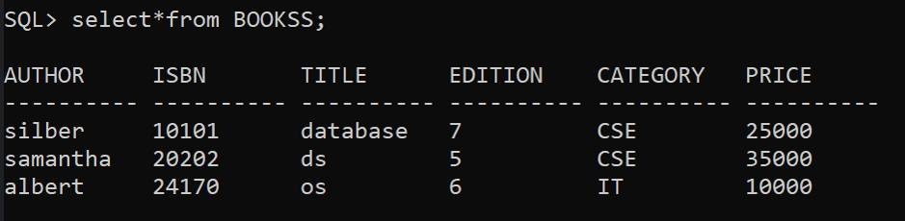

2.INSERT:
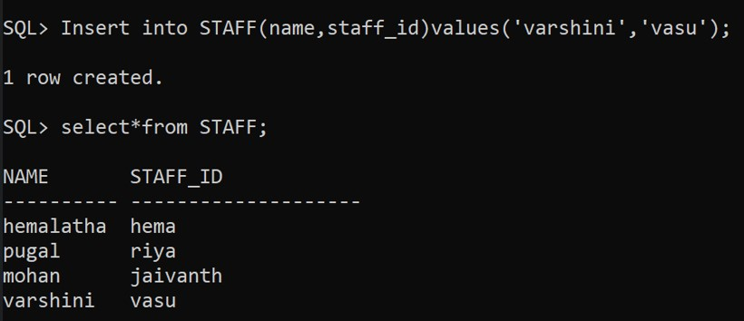
3.UPDATE:
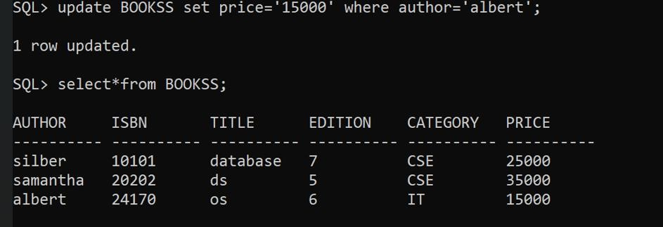

4.DELETE:
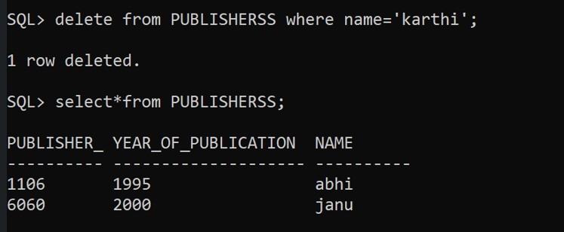

TRANSACTION CONTROL COMMMANDS:
1.DESCRIPTON:
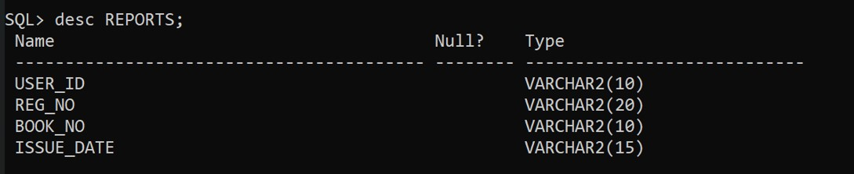
2.COMMIT:

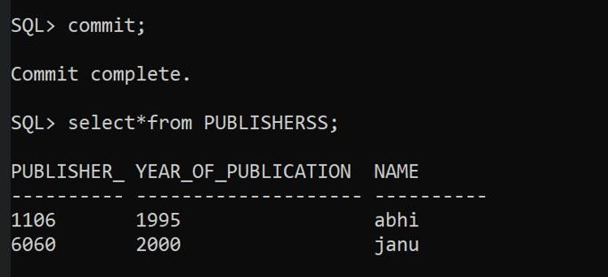
3.SAVEPOINT:
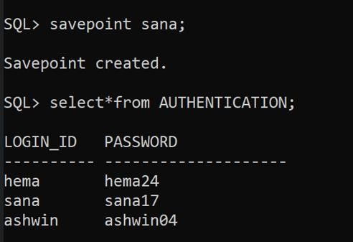

4.ROLLBACK:
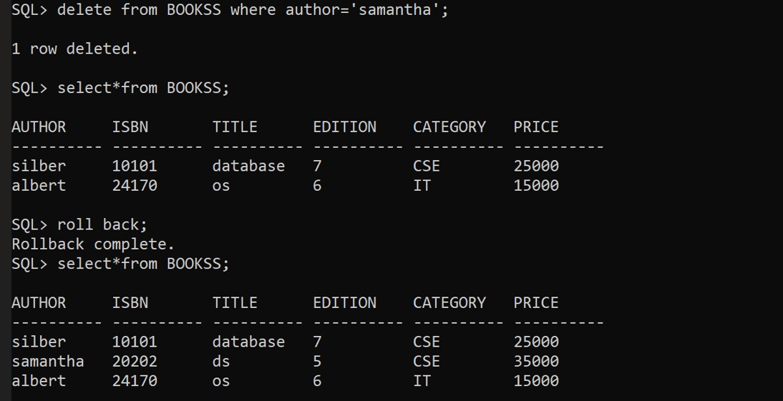

ARITHMETIC OPERATORS

1.MAX:
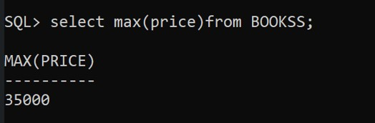
2.MIN:
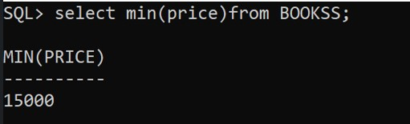
3.COUNT:
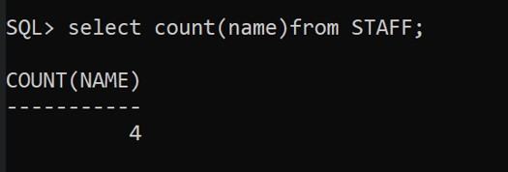

4.AVERAGE:
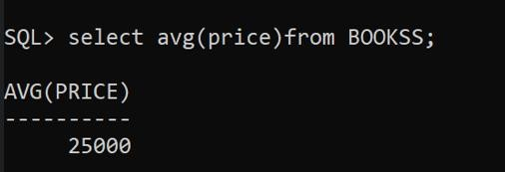
5.SUM:
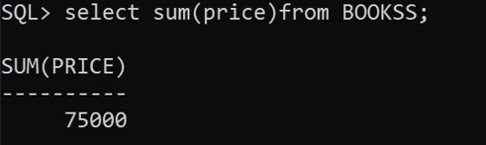

SET OPERATORS:

UNION:
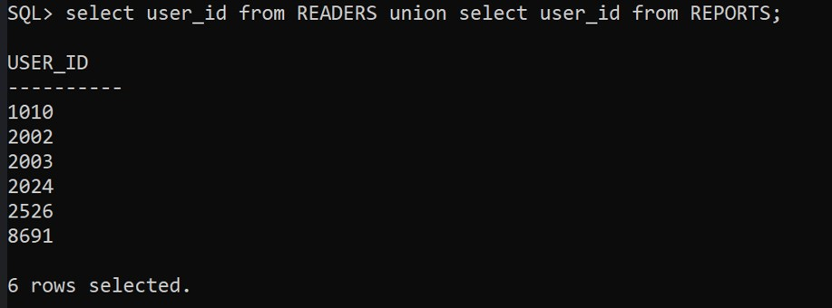

UNION ALL:

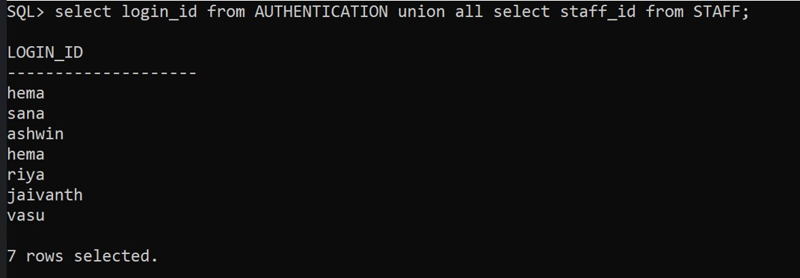

MINUS:

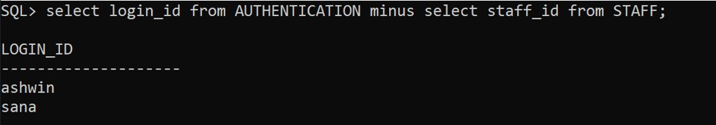

INTERSECT:

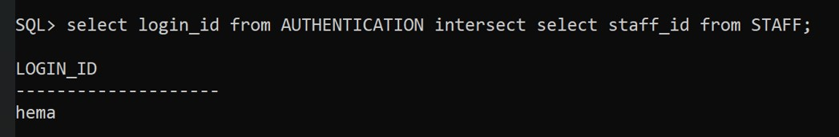

DATA QUERY LANGUAGE:
1.SELECT:
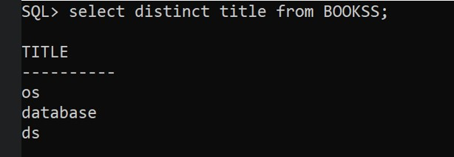

2.ORDER BY CLAUSE:
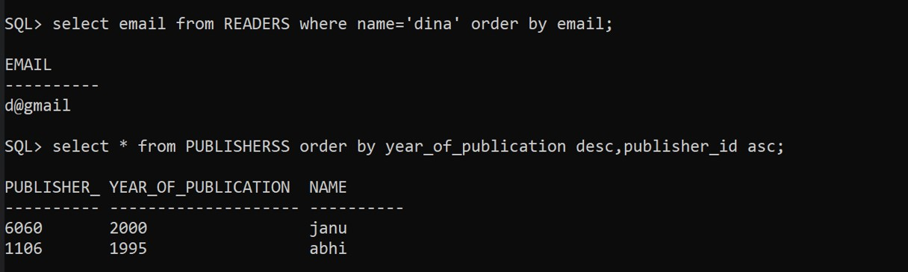

3.GROUP BY CLAUSE:
